475 Moreland Avenue SE, Suite C
Atlanta, GA 30316
Phone: 404.622.4116
Fax: 404.622.4118
Email: staff@411south.com

ANGEL DANIEL JIMENEZ
_________________________________________________
HEIGHT: 6’ WEIGHT: 150 HAIR: BLACK EYES: BROWN

TELEVISION
Novant Thanksgiving Parade Opener (2016) Dancer WBTV Channel 3 (CBS)
Novant Thanksgiving Parade Opener (2017) Dancer WBTV Channel 3 (CBS)

MOVIE
“Night School” Dancer Chor: Eboni Nichols

MUSIC VIDEOS
The Gore Boyz “Let’s Go” Dancer Chor: Chuck Maldonado
The Gore Boyz “Handclap” Dancer Chor: Chuck Maldonado
Brooke Hammel “Favorite Song” Classroom Boy BNR Worldwide
Brayden Taylor “Make Me Wanna Say” Dancer Chor: Dres Reid

STAGE/LIVE PERFORMANCES
Behind the Movement Dancer Jeremy Green Productions
Center City Vision Awards Dancer Fuzion Force Entertainment
High Velocity Dance Crew Dancer Fuzion Force Entertainment
Split Second Sound Dancer/Party Motivator Split Second Sound Entertainment
Brayden Taylor (Singer/Artist) Backup Dancer Chor: Dres Reid
The Gore Boyz (Boy Band) Backup Dancer Chor: Chuck Maldonado
Elevation Church Featured Dancer Elevation

TRAINING
Havilah Dance Company Hip-hop, Ballet, Jazz, Contemporary, Musical Theater, Partnering
Fuzion Force Entertainment Academy Hip-hop, B-boy basics
Northwest School of the Arts Ballet, Modern, Contemporary
Chuck Maldonado Live Stage Backup Dancing, Hip-hop
Monsters of Hip Hop Hip-hop, Jazz Funk
Radix Hip-hop, Jazz, Ballet, Contemporary, Musical Theater, Modern
Millennium Dance Complex LA Hip-hop, Jazz Funk
Broadway Dance Center Hip-hop, House
Debbie Reynolds Dance Studio Hip-hop
Movement Lifestyle Hip-hop

SPECIAL SKILLS
Hip-hop, Contemporary, Choreography, Drum Set, Piano, Deejaying, Music production, Fluent in Spanish, Basketball

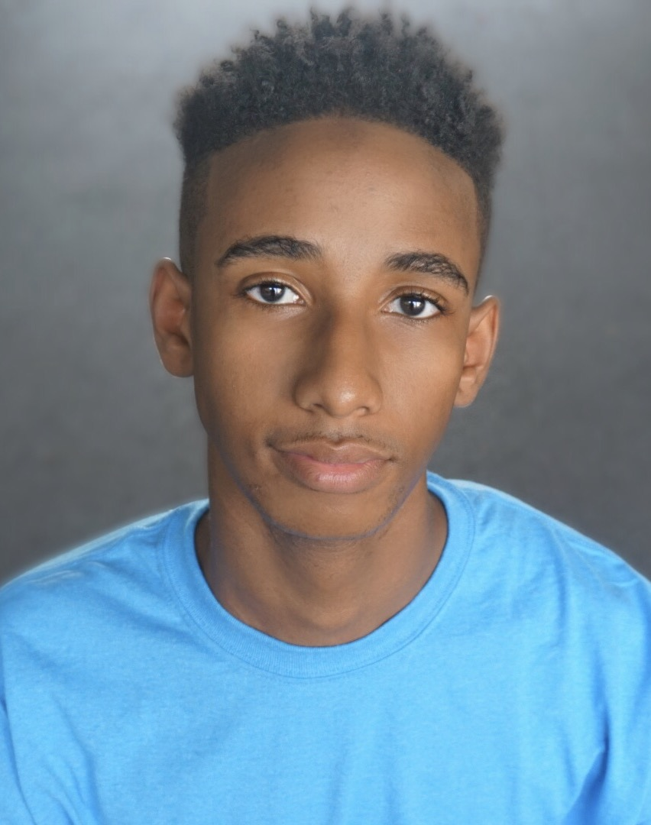

ANGEL DANIEL JIMENEZ

