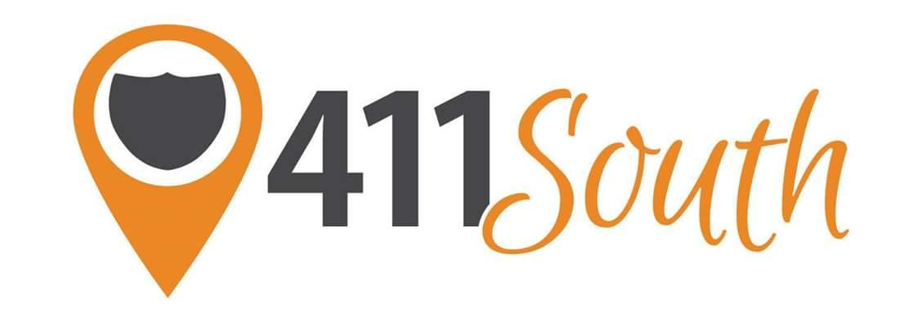
411 South
475 Moreland Ave. SE, Suite C
Atlanta, GA 30316

Office: 404-622-4116
Fax: 404-622-4118

staff@411south.com

Bryce Speaker
Height: 5’10”
Eyes: Brown
Hair Color: Black

Television/Film
Crazy For The Boys Principal Dancer Chor: Dexter Carr
The Darkest Minds Principal Dancer Chor: Sean Bankhead

Music Videos
Chuck Berry: Big Boys Featured Dancer Chor: Jeremy Green

Live/Stage Performances
Miss Georgia USA Pageant 2017 Principal Dancer Chor: Evari Pickett
Going Dutch Festival Chicago Dancer Chor: Shannon Phillips
Burlesque (University Dance Theater) Featured Soloist Chor: Nikki Sangiacomo
American College Dance Association Featured Soloist Chor: Lara Little
Underground Cabaret Dancer/Singer (Musical) Chor: Lysa Fox
When Johnny Comes Marching Home Soloist (Musical) Chor: Lara Little

Training
Dance:
Western Illinois University Dance Theater Lara Little, Candace Winters-March
Gotta Dance Contemporary Company Rachel Truitt, Jon Carr, CiCi Kelley
Dance 411: Rikki Mckinney, Jeremy Green,
Charles Guyton, Brooke Bowe,
Bryan Merritt, Anthony Marquis

Special Skills
Elite Gymnastics (Full-Twisting Layout), Hip Hop, Contemporary, Jazz, Tap, Ballet, Modern, African, Graham, Horton, Partnering, Cheerleading, Acro, Swimming

